**Matrix visualization**

**Introduction**

When you are presenting tabular information in a Microsoft Power BI report page or dashboard, it is important that the key results and insights do not get lost in a flood of information. Large blocks of data in rows and columns can often be difficult for people to read and assimilate. The matrix visualization in Power BI is a powerful tool that gives the report viewer control over how much or how little information they see in the table. It also allows them to interactively generate focused totals and results as required.

**What is a matrix visual?**

The matrix visual is similar to a table but has key features that allow the report designer to communicate multiple levels of information in the data. A table supports two dimensions, and the data is flat, meaning duplicate values are displayed and not aggregated. On the other hand, a matrix makes it easier to display data meaningfully across multiple dimensions because it supports a stepped layout. Unlike the table, the matrix automatically aggregates the data, enabling the viewer to drill down into the detail.

When you create matrix visuals in a Microsoft Power BI report, you can cross-highlight elements within the matrix with other visuals on that report page. For example, you can select rows, columns, and even individual cells and cross-highlight. Also, individual cells and multiple cell selections can be copied and pasted into other applications.

There are many features associated with the matrix, which you’ll explore in the following sections of this reading.

**Understanding how Power BI calculates totals**

Before using the matrix visual, it's essential to understand how Power BI calculates total and subtotal values in tables and matrices. When creating **total** and **subtotal rows**, Power BI does not just perform a simple addition of the values in the visible or displayed rows. Instead, it evaluates the measure over all rows in the underlying data, which means you can end up with different values in the total row than you might expect.

Let’s explore the following visuals.

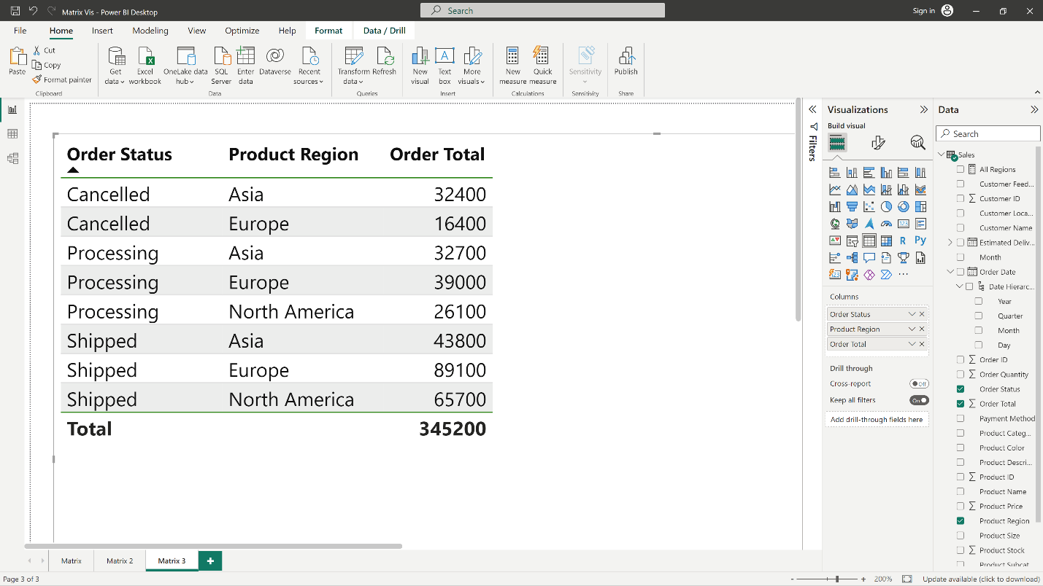

In this example, each row in the visual displays an amount for each order status combination. What is immediately apparent is that the figure in the total row does not seem to be correct for the entries in the column above. Because an order status shows up against multiple regions, their totals appear more than once. This is why the accurate total from the underlying data in the total row and a simple addition of the visible values do not match. This is a common pattern when the value you’re summing is on the ‘one’ side of a one-to-many relationship.

When you examine totals and subtotals, remember that those values are based on the underlying data. They aren't solely based on the values visible in the rows above.

**Expanding and collapsing row headers**

There are two ways you can expand row headers. The first is through the right-click or context menu. There are options to expand the specific row header you selected, the entire level, or everything down to the very last level of the hierarchy. There are similar options for collapsing row headers as well.

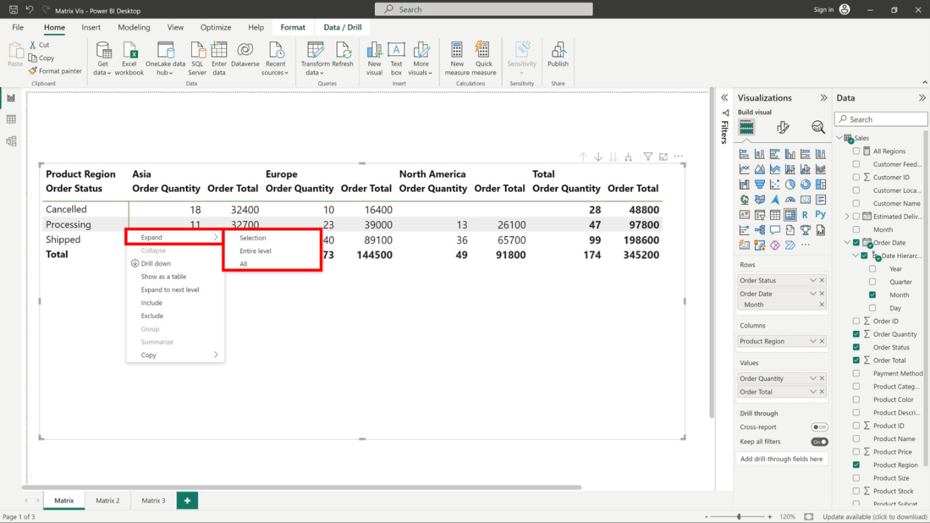

You can also add **+/-** buttons by selecting them in the **Row Headers** card in the **Format** pane. By default, the icons will match the formatting of the row header, but you can customize the icons’ colors and sizes separately if you want. Once the icons are turned on, they work in a similar way to these icons in Excel PivotTables.

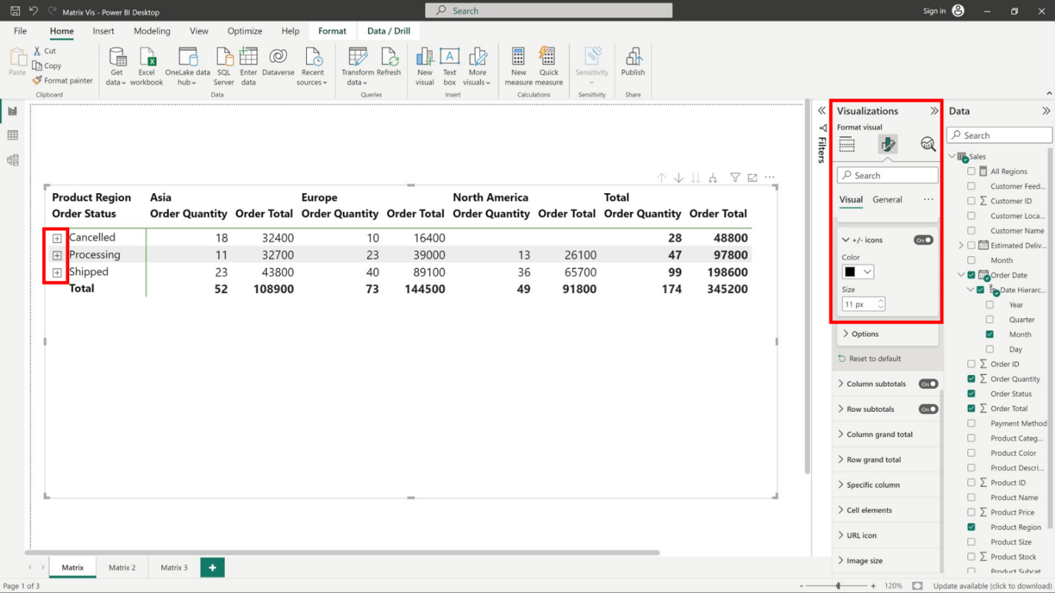

The expansion state of the matrix will be saved when you save your report. A matrix can be pinned to a dashboard in an expanded or collapsed form. When that dashboard tile is selected and the report opens, the expansion state can still be changed in the report.

**Drill down on row headers**

When you add multiple fields to the **Rows** section of the **Fields** well in the **Visualizations** pane, you also enable drill-down actions on the rows of the matrix visual. This is similar to creating a hierarchy. You can drill down and then back up through that hierarchy and analyze the data at each level.

In the following image, the **Rows** section contains **Sales** stage and **Opportunity** size, creating a grouping (or hierarchy) in the rows that you can drill to view details.

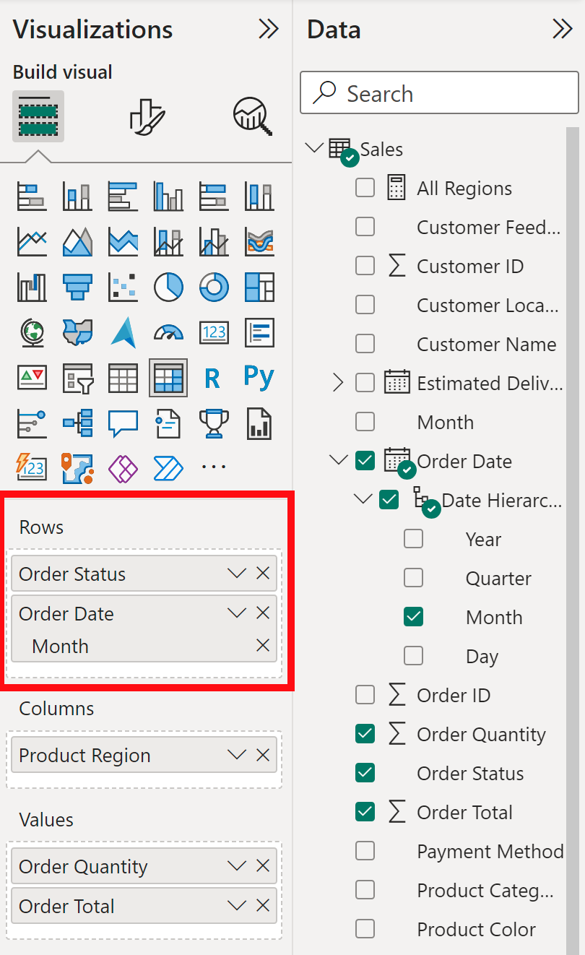

When the visual has a grouping created in the **Rows** section, the visual itself displays the **Drill** and **Expand** icons in the top corner of the visual.

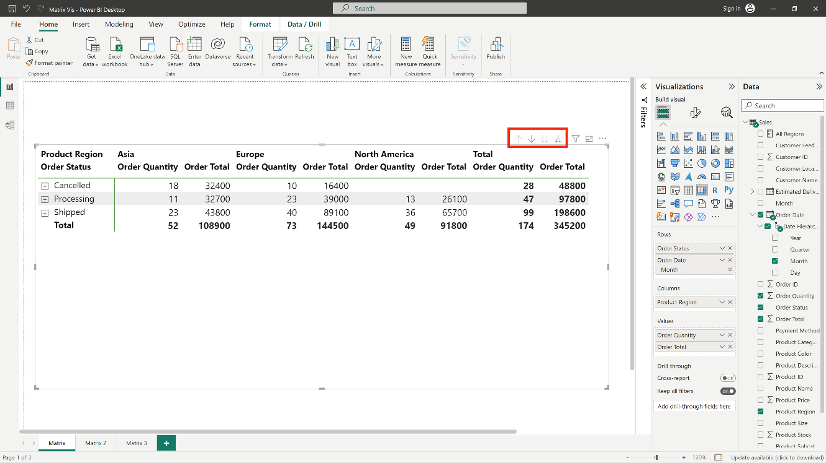

Similar to the drill and expand behavior in other visuals, selecting those buttons allows you to drill down (or back up) through the hierarchy. In this example, selecting the **Drill down one level** icon (the pitchfork) drills down from **Sales** to further details by **Months**, as displayed in the following image.

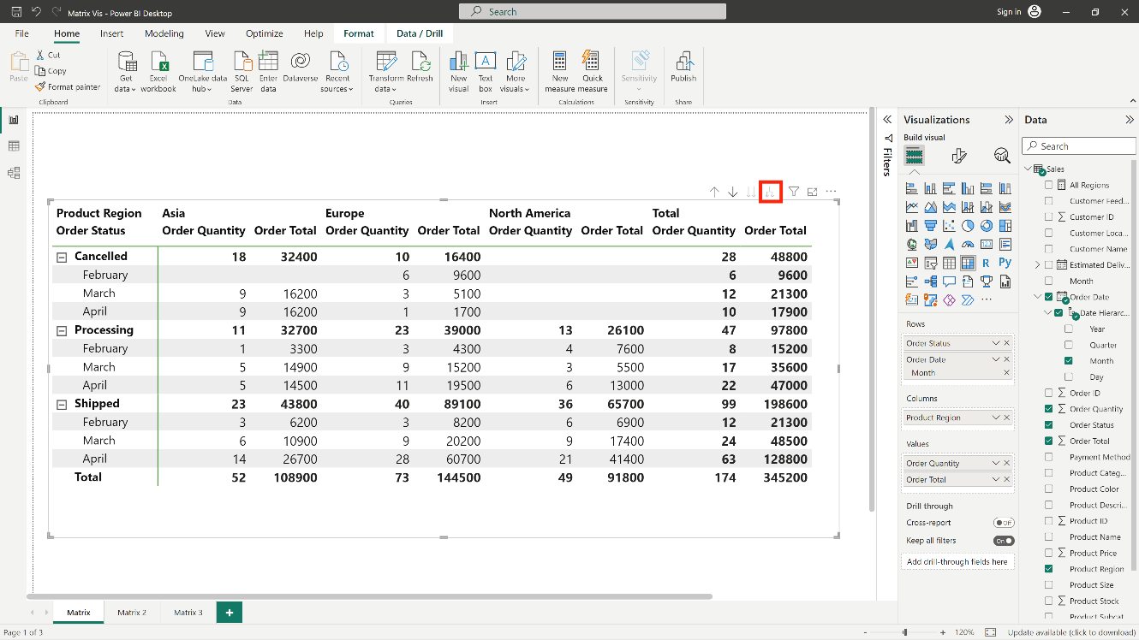

Another way to drill down is to select any row header and choose from the menu that appears.

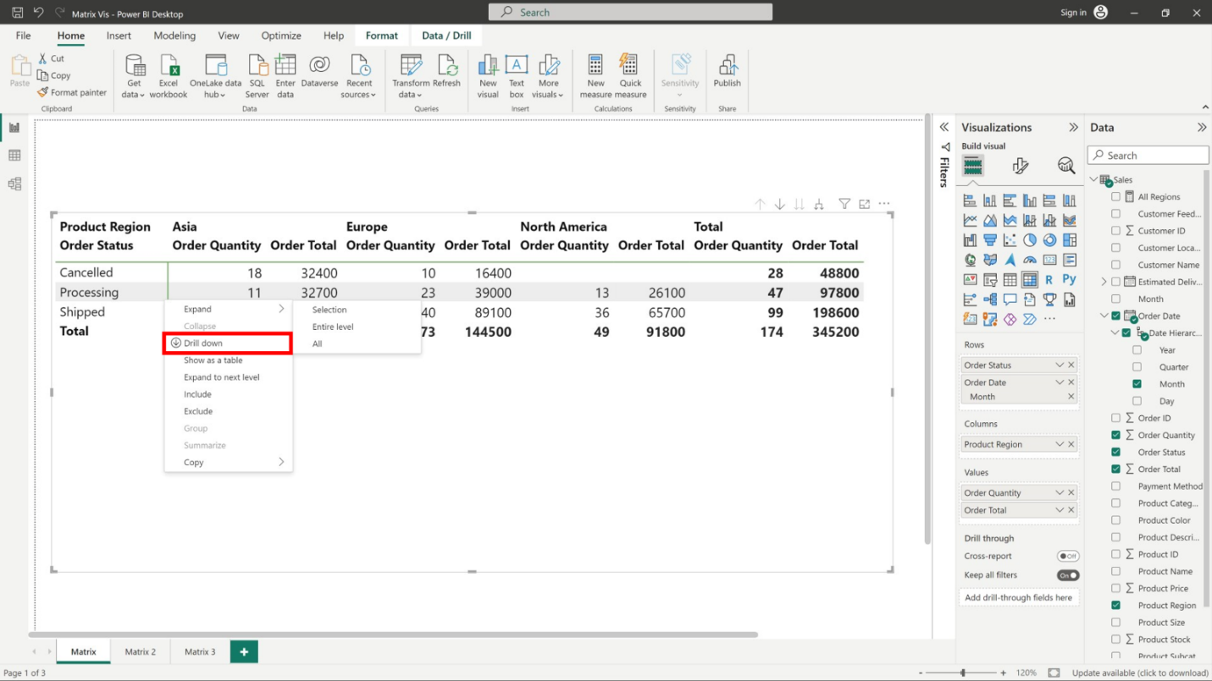

Selecting **Drill down** from the menu that appears expands the matrix for that row level and excludes all other row headings except the row header that was selected.

In the following image, **Cancelled** > **Drill down** was selected. Notice that other top-level rows no longer appear in the matrix. This is a useful drill feature, particularly for cross-highlighting.

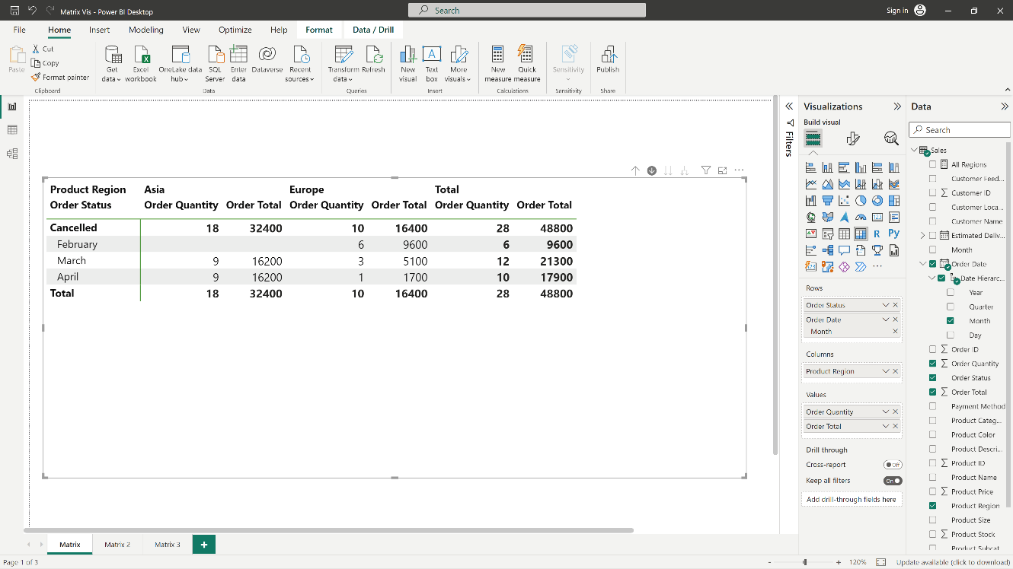

Select the **Drill up** icon to get back to the previous top-level view. If you then select **Cancelled** > **Show next level**, you get an ascending listing of all the next-level items (in this case, the **Month** field) without the higher-level hierarchy categorization.

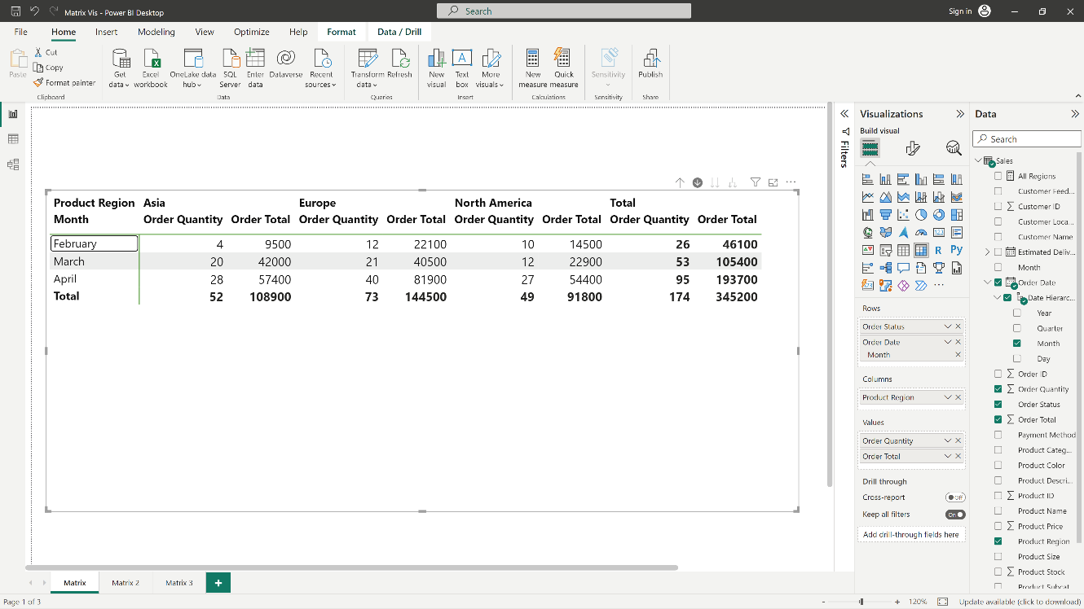

Select the **Drill up** icon in the upper corner to have the matrix display all top-level categories, then select **Cancelled** > **Expand to next level** to view all the values for all levels of the hierarchy **Order Status** and **Month**.

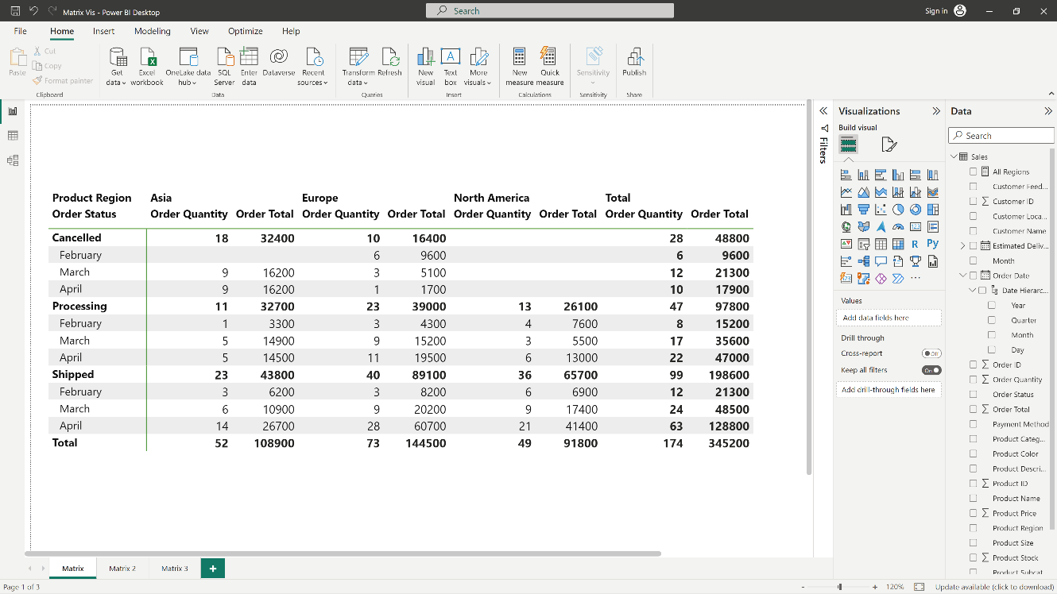

You can also use the **Expand** menu item to control the display further. For example, select the **Drill up** icon. Then select **Cancelled** > **Expand** > **Selection**. Power BI displays one total row for each **Sales stage** and all the **Opportunity size** options for **Proposal**.

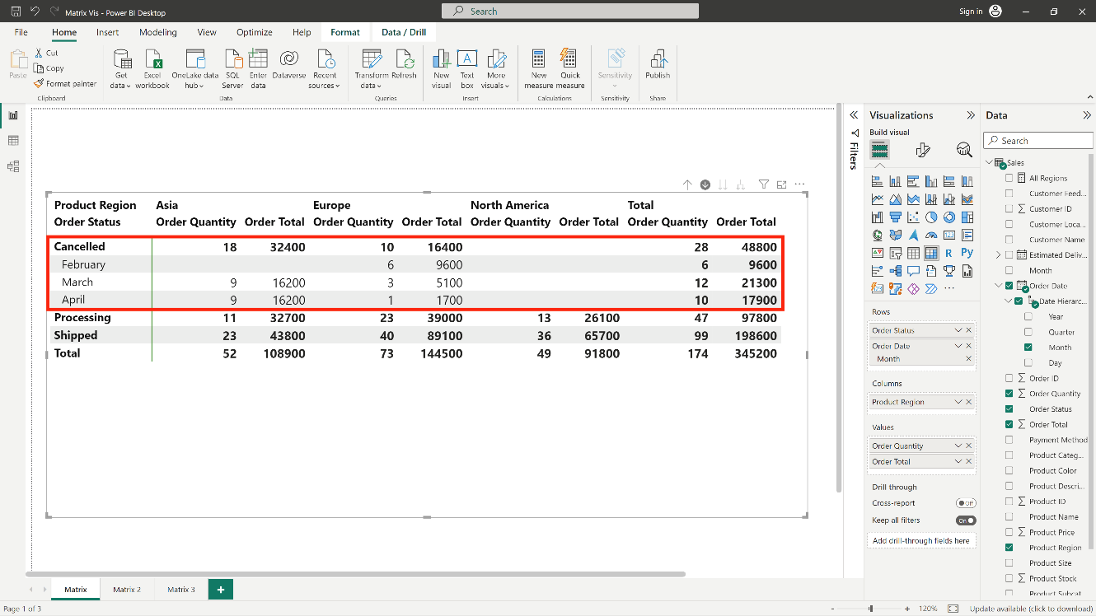

**Drill down on column headers**

Just as you can drill down on rows, you can also drill down on columns. In the following image, there are two fields, **Region** and **Order Date Month**,in the **Columns** field well, creating a hierarchy. As soon as the second field is added to **Columns**, a new dropdown menu choice labeled **Drill on** is displayed on the visual to the left of the drill and expand icons. It currently shows **Rows**.

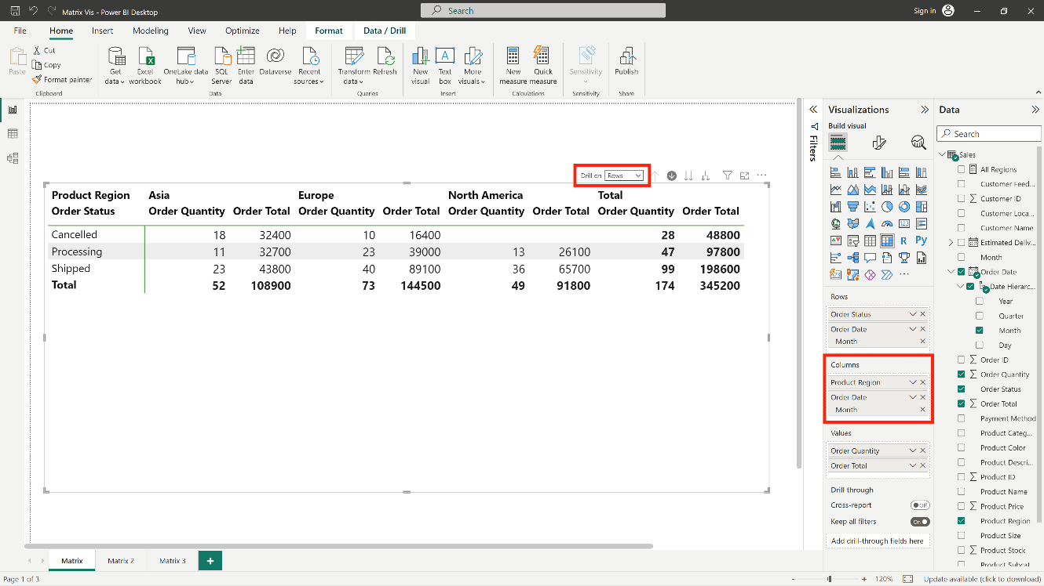

To drill down on columns, change the selection on the **Drill on** menu to **Columns**. Then select the **Europe** region and choose **Drill down**.

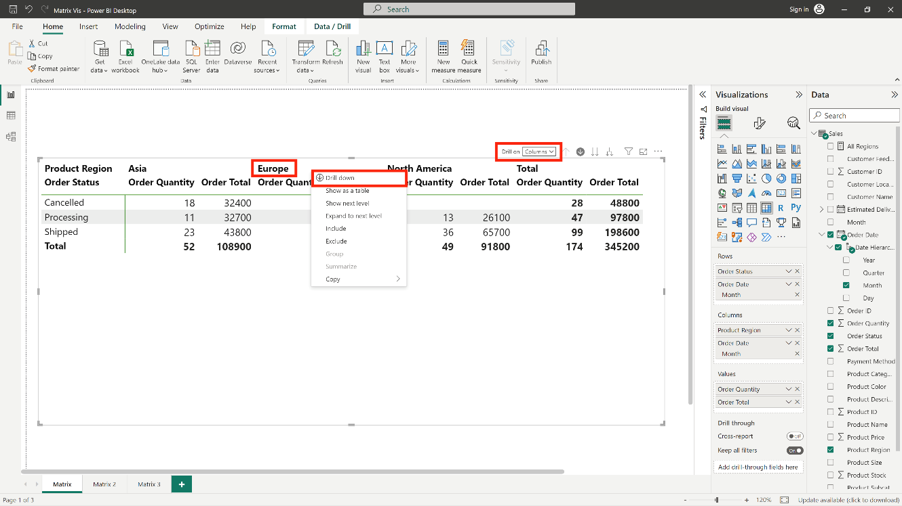

When you select **Drill down**, the next level of the column hierarchy for **Region** > **Europe** displays, which in this case is **Monthly Order Status**. The other region is hidden.

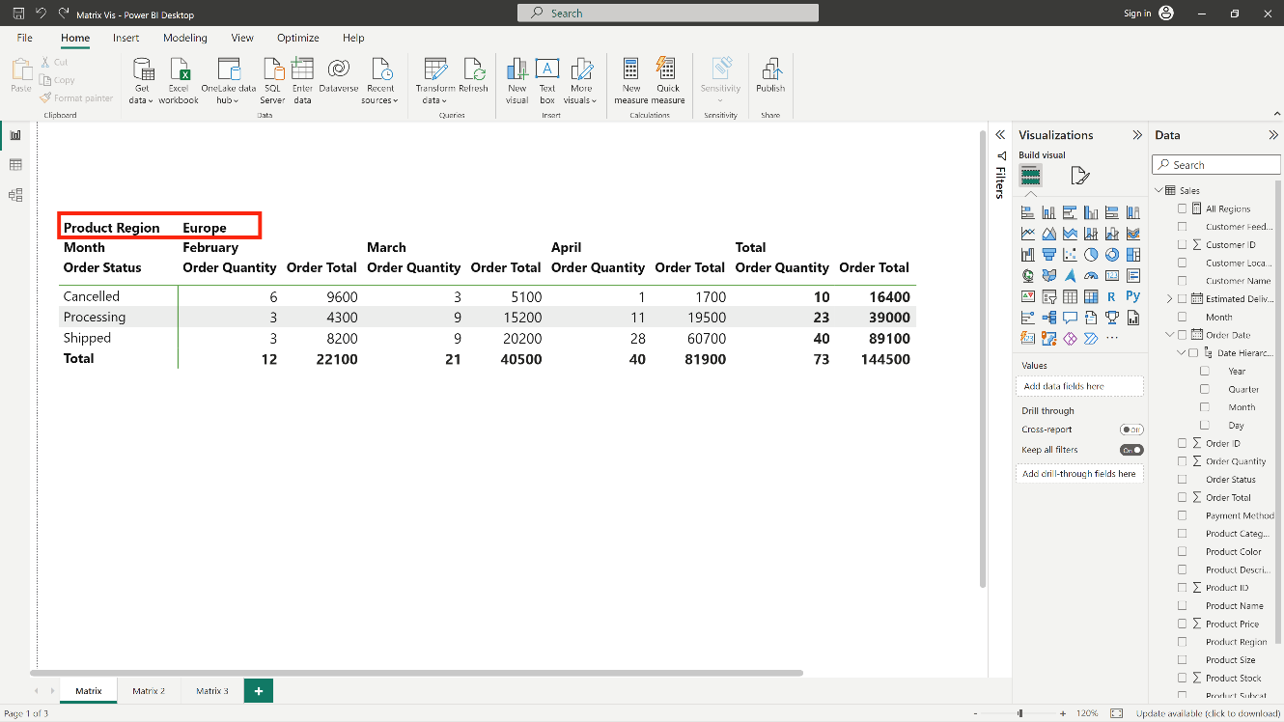

The rest of the menu items work on columns in the same way they do for rows (see the previous section, **Drill down on row headers**). You can **Show next level** and **Expand to next level** with columns just as you can with rows.

**Note:** The drill-down and drill-up icons only apply to rows. To drill down on columns, you must use the right-click or context menu.

**Stepped layout with matrix visuals**

The matrix visualcreates a **Stepped layout** by automatically indenting subcategories in a hierarchy beneath each parent. In the original version of a matrix visual, subcategories are shown in a different column, which takes up space in the visual, as shown in the following image.

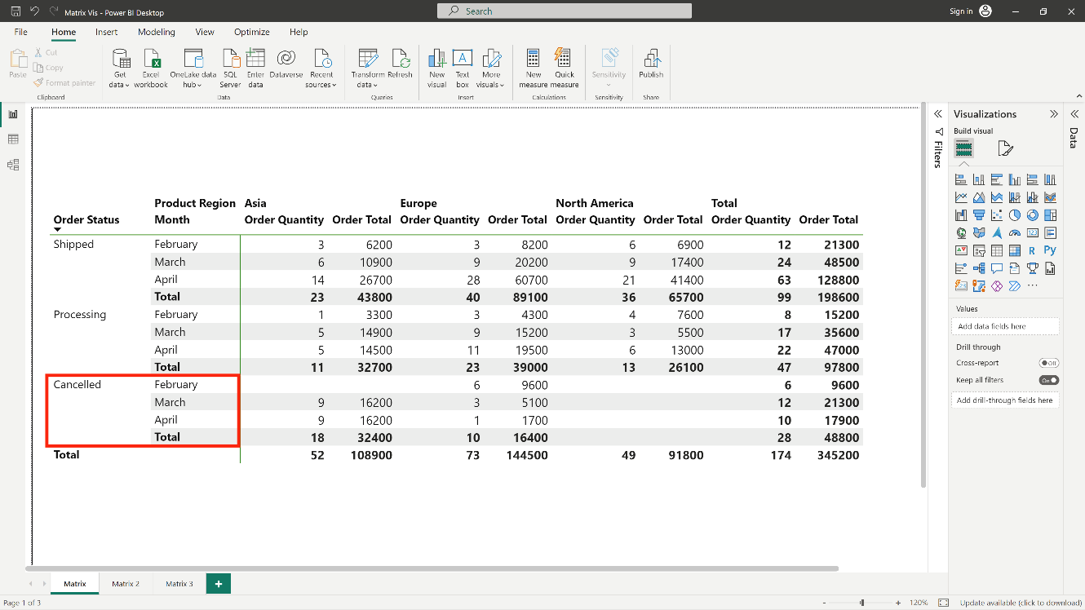

However, the following image displays a matrix visual with **Stepped layout**. Notice that the category **Month** has its subcategories (**February**, **March**, and **April**) slightly indented, providing a cleaner and more condensed display.

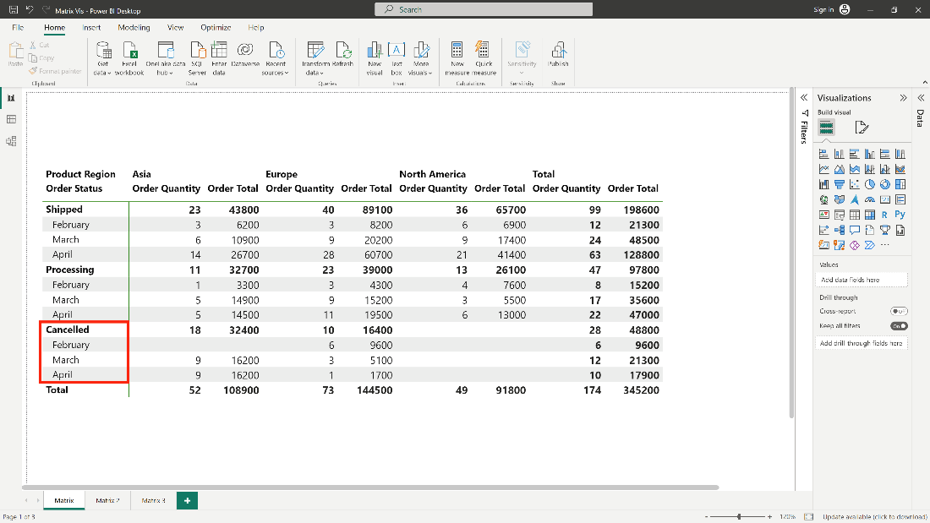

**Formatting the Stepped layout**

You can easily adjust the **Stepped layout** settings. Select the matrix visual**,** and then, in the **Format** section (the paintbrush icon) of the **Visualizations** pane, expand the row headers section.

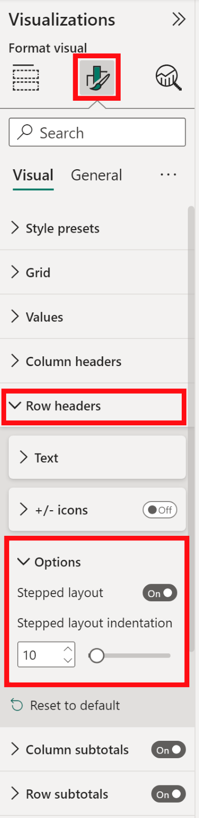

There are two options here. The **Stepped layout** can be turned on or off using the toggle. The indentation amount in pixels can be set in **Stepped layout indentation.**

If you turn off the **Stepped layout**, Power BI displays the subcategories in another column rather than indented beneath the parent category.

**Subtotals and grand totals with matrix visuals**

You can turn subtotals on or off in matrix visuals for both rows and columns. In the following image, the row subtotals are set to **On** and to display at the bottom.

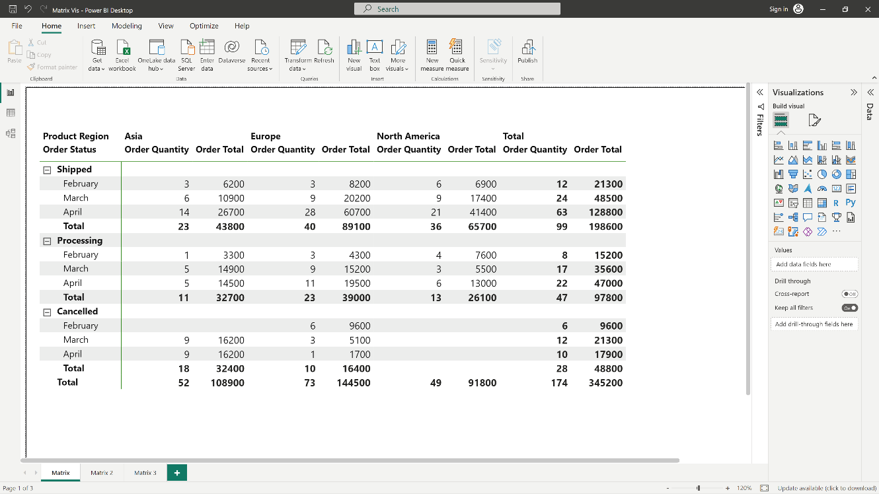

When you turn on **Row subtotals** and add a label, Power BI also adds a row and the same label for the grand total value. To format the **Grand total**, select the format option for **Row grand total**.

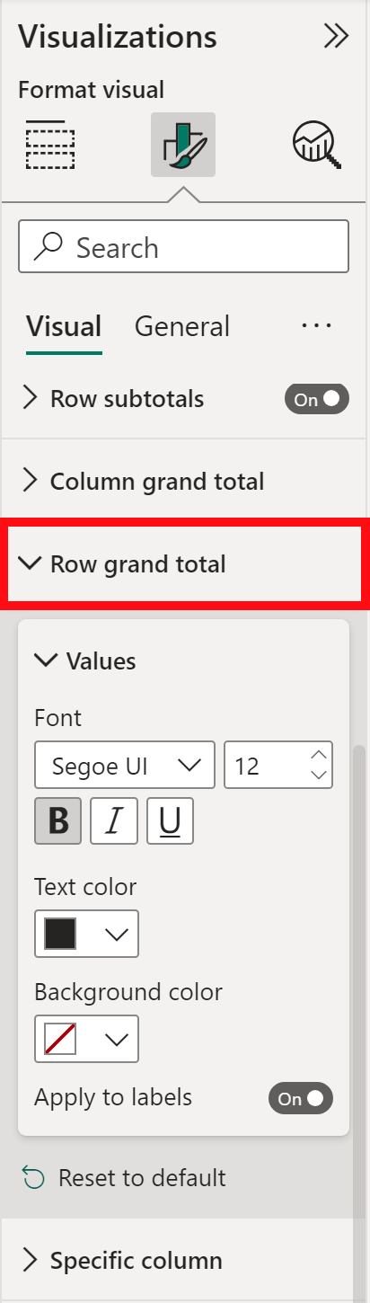

If you want to turn subtotals and the grand total off, in the format section of the **Visualizations** pane, expand the **Row subtotals** card. Turn the row subtotals slider to **Off**. When you do so, the subtotals aren't displayed.

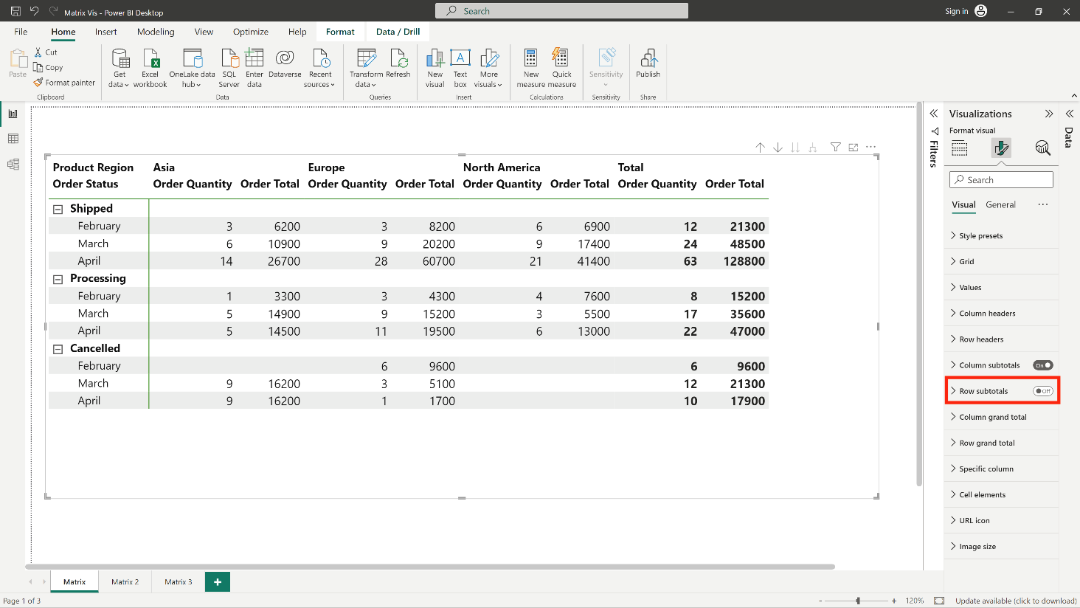

The same process applies to column subtotals.

**Conclusion**

The matrix visualization is a dynamic tool in Microsoft Power BI that can enhance reports and dashboardsand provide a more exciting overall experience. By using a matrix visualization, a Power BI analyst can include a large amount of data that is relevant to diverse audiences. They can do this secure in the knowledge that the individual users can interact with the data in a dynamic way and drill down to find the specific answers to the questions they are asking.